Design Thinking Project Report on
GPING APPLICATION
Submitted to
The Department of Computer Science and Engineering (Cyber Security)
Bachelor of Technology in
Computer Science and Engineering (Cyber Security) (2022 – 2026)
G. Rohith 22R11A6213
P. Sai Charan Goud 22R11A6233
R. Sandeep Goud 22R11A6235

Under the Guidance of
Mrs. M. Prajwala Priyanka


Department of Computer Science and Engineering (Cyber Security)
Geethanjali College of Engineering and Technology (UGC Autonomous)
(Affiliated to J.N.T.U.H, Approved by AICTE, New Delhi, Accredited by NBA)
Cheeryal (V), Keesara (M), Medchal.Dist.-501 301.
June-2024

ABSTRACT

The GPING Navigation Application is an innovative solution designed to transform the navigation experience within college campuses by leveraging the principles of design thinking. Recognizing the unique challenges faced by students, faculty, and visitors in navigating complex campus environments, GPING is built on a foundation of empathy and user-centered design. The application addresses these diverse needs through an array of sophisticated features that enhance usability, accuracy, and reliability. At its core, GPING offers an interactive map interface that provides users with a visual representation of the campus layout, complete with zoom and pan functionalities and points of interest (POIs). This feature is complemented by a searchable room database, allowing users to quickly and efficiently locate specific rooms, buildings, and facilities. To accommodate individual preferences and requirements, GPING includes customizable routes, enabling users to select paths based on accessibility, speed, or personal preferences. GPING’s integration with college databases is a critical component, providing users with up-to-date information on course locations, event schedules, and available facilities. This seamless integration ensures that users have comprehensive access to all necessary campus information in one place. Additionally, the application prioritizes user privacy and data security through robust encryption methods and strict compliance with privacy standards, fostering a trustworthy user environment. The development of GPING is characterized by continuous iteration and user feedback loops, ensuring that the application evolves in response to the changing needs and preferences of its users. This commitment to ongoing improvement, combined with its advanced feature set and user-centered design, positions GPING as a pioneering solution in campus navigation. In summary, GPING represents a significant advancement in navigation technology for educational environments. By addressing the specific needs of campus users and leveraging the principles of design thinking, GPING enhances the overall user experience, making campus navigation more intuitive, efficient, and reliable. This application not only exemplifies innovation in design but also sets a new standard for how navigation tools can be effectively integrated into educational settings to support diverse user needs.

INDEX

ABSTRACT

1. INTRODUCTION 1

1.1 EXISTING SYSTEM 2
1.2 PROPOSED SYSTEM 2

2. SYSTEM ANALYSIS 3

2.1 SOFTWARE REQUIREMENTS 3
2.2 HARDWARE REQUIREMENTS 4

3. SYSTEM DESIGN 5

3.1 ARCHITECTURE DESIGN 5
3.2 FLOWCHART 6
3.3 MINDMAP DIAGRAM 7

4. CODE IMPLEMENTATION 8

5. RESULTS 19

- CONCLUSION 22

- FUTURE SCOPE 23

8. REFERENCES 24

1. INTRODUCTION

Navigating college campuses can often be a daunting task, given their sprawling layouts, numerous buildings, and intricate room numbering systems. For students, faculty, and visitors alike, finding specific locations, planning routes, and accessing timely information about campus events and facilities can be challenging. To address these issues, the GPING Navigation Application has been developed, offering a revolutionary approach to campus navigation. GPING is a state-of-the-art navigation app specifically designed to enhance the user experience within college campuses. It is built on the principles of design thinking, emphasizing empathy, user-centered design, and continuous improvement. The app's primary goal is to simplify the complexities of campus navigation and provide users with a seamless, efficient, and reliable way to find their way around. Key features of GPING include an interactive map interface that allows users to easily visualize the campus layout, search for specific rooms, buildings, and facilities, and access points of interest (POIs).
The app also offers customizable routes, enabling users to choose paths based on their preferences, such as the fastest route or one that accommodates accessibility needs. Real-time location tracking and dynamic route adjustments ensure that users receive accurate and up-to-date navigation information, while offline functionality guarantees that essential features remain accessible even without an internet connection. In conclusion, GPING represents a significant advancement in campus navigation technology. By leveraging design thinking principles and focusing on the specific needs of college campus users, GPING offers a comprehensive and user-friendly solution that revolutionizes the way people navigate educational environments.

1.1 EXISTING SYSTEM

- Conventional navigation applications provide basic mapping and routing functionalities but may not be tailored to the specific needs of navigating college campuses.
- These apps might lack real-time location tracking, route adjustments, and offline functionality, which are essential for navigating large and complex educational environments.
- Privacy concerns may arise due to the collection of user data by conventional navigation apps.

1.2 PROPOSED SYSTEM

- User-Centric Design: GPING prioritizes the needs of students, faculty, and visitors by providing a human-centric approach to navigating college campuses.

- Real-Time Location Tracking: The application offers real-time location tracking, allowing users to navigate efficiently within the campus environment.

- Route Adjustments: GPING constantly iterates and tests its features based on user feedback, ensuring that it can make route adjustments on the fly to accommodate changes in the campus environment.

- Integration with College Databases: The application integrates with college databases to provide accurate and up-to-date information about campus buildings, facilities, and events.

2. SYSTEM ANALYSIS

2.1 SOFTWARE REQUIREMENTS

Operating System:
- Windows 10 or later
- macOS 10.15 or later
- Linux distributions with kernel version 4.15 or later
- iOS 13 or later
- Android 8.0 (Oreo) or later

Software:
- Updated web browser (for web-based interface)
- GPS and location services enabled
- Bluetooth enabled (for real-time tracking and indoor navigation)

Network:
- Internet connection for initial setup, map downloads, and updates
- Offline functionality supported through cached data.

2.2 HARDWARE REQUIREMENTS

Processor:
- Minimum: Dual-core CPU (2.0 GHz or faster)
- Recommended: Quad-core CPU (2.5 GHz or faster)

Memory (RAM):
- Minimum: 2 GB
- Recommended: 4 GB or more

Storage:
- Minimum: 100 MB of available space for application installation
- Additional space for cached maps and routes, depending on campus size (typically 500 MB to 1 GB)

Display:
- Minimum: 4.7-inch screen with 720p resolution
- Recommended: 5.5-inch screen or larger with 1080p resolution or higher

GPS:
- Built-in GPS receiver for real-time location tracking
- Support for GLONASS and Galileo (optional but recommended for improved accuracy)

Sensors (optional but recommended for enhanced functionality):
- Accelerometer
- Gyroscope
- Compass.

3. SYSTEM DESIGN

3.1 ARCHITECTURE DESIGN

Users
Login
Interactive Map Interface
Searchable Rooms Database

Real-time Location Tracking
Offline Functionality
Integration with College Databases
Privacy and Security
Customizable Routes
GPING APP
Database of Campus Information
Buildings
Rooms
Facilities
Events
Backend Server
Details about Locations
Room Numbers
Building Names
Accessibility Features

Fig 3.1 Architectural Design

3.2 FLOW CHART

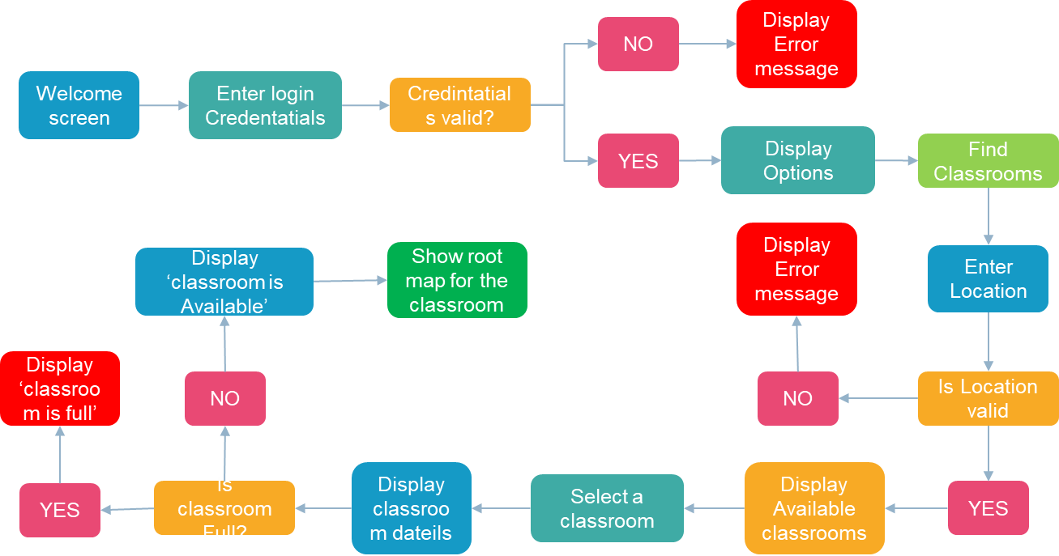

Fig 3.2 Flow Chart

3.3 MINDMAP DIAGRAM

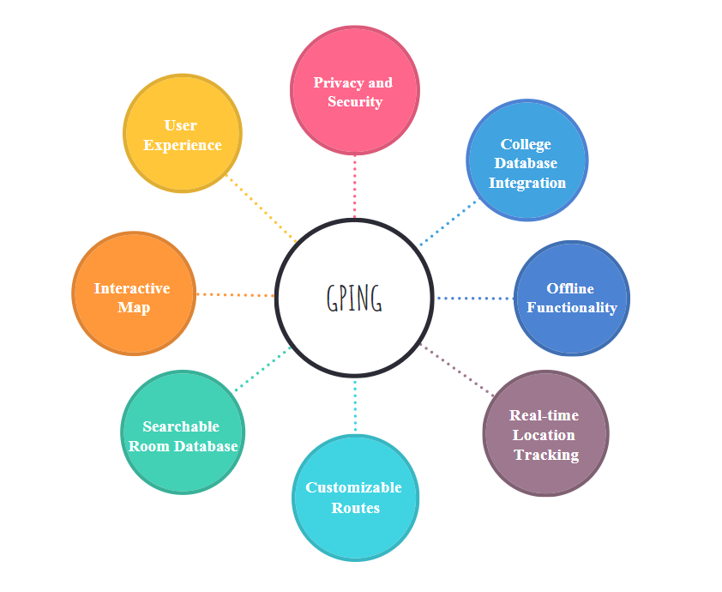

Fig 3.3 MindMap Diagram

4. CODE IMPLEMENTATION

Index.html

<!DOCTYPE html>
<html lang="en">
<head>
<meta charset="UTF-8">
<meta name="viewport" content="width=device-width, initial-scale=1.0">
<script src="https://aframe.io/releases/1.2.0/aframe.min.js"></script>
<link rel="stylesheet" href="styles.css">
<link rel="stylesheet" href="https://cdn.pannellum.org/2.5/pannellum.css">
<title>Navigation App</title>
</head>
<body>
<div id="welcomeScreen">
<h1>Welcome to the Navigation App</h1>
<button onclick="showNavigation()">Let's Navigate</button>
</div>

<div id="navigationScreen" style="display: none;">
<button onclick="showBlock(5)">Block 5</button>
<button onclick="goBack()">Go Back</button>
</div>

<div id="blockScreen" style="display: none;">
<button onclick="showFloor(1)">Floor 1</button>
<button onclick="showFloor(2)">Floor 2</button>
<button onclick="showFloor(3)">Floor 3</button>
<button onclick="goBack()">Go Back</button>
</div>

<div id="floorScreen" style="display: none;">
<!-- Room buttons will be dynamically added here -->
<button onclick="goBack()">Go Back</button>
</div>

<div id="roomScreen" style="display: none;">
<h2>360-degree Panoramic Photo</h2>
<a-scene>
<a-sky id="aframeSky" rotation="0 -130 0"></a-sky>
</a-scene>
<button onclick="goBack()">Go Back</button>
<button onclick="navigateToNextPhoto()">Next Photo</button>
</div>

<div id="panoramicContainer" style="display: none;">
<div id="panoramicPhoto"></div>
<button class="hotspot" style="left: 50%; top: 30%;" onclick="navigateToPhoto('room102photo.jpg')">
<i class="fas fa-arrow-up"></i>
</button>
<!-- Add more hotspots as needed -->
<button id="fullScreenBtn" onclick="toggleFullScreen()">Toggle Full Screen</button>
</div>

<script src="https://cdn.pannellum.org/2.5/pannellum.js"></script>
<script>
const roomPhotos = ['room101photo.jpg', 'room102photo.jpg', /* Add more photos as needed */];
let currentRoomIndex = 0;

function navigateToPhoto(newPhoto) {
// Use Pannellum to load the new photo
viewer.loadScene({
panorama: newPhoto,
pitch: 0,
yaw: 0,
hfov: 100,
});

// Show the Pannellum container
document.getElementById('panoramicContainer').style.display = 'block';
// Hide the A-Frame scene
document.getElementById('roomScreen').style.display = 'none';

// Exit full screen if it's active
exitFullScreen();
}

function navigateToNextPhoto() {
currentRoomIndex = (currentRoomIndex + 1) % roomPhotos.length;
const nextPhoto = roomPhotos[currentRoomIndex];
navigateToPhoto(nextPhoto);
}

function showNavigation() {
document.getElementById('welcomeScreen').style.display = 'none';
document.getElementById('navigationScreen').style.display = 'block';
// Push the current state to the browser history
history.pushState({ page: 'navigation' }, 'Navigation', '#navigation');
}

function showBlock(blockNumber) {
document.getElementById('navigationScreen').style.display = 'none';
document.getElementById('blockScreen').style.display = 'block';
// Push the current state to the browser history
history.pushState({ page: 'block', blockNumber }, `Block ${blockNumber}`, `#block${blockNumber}`);
}

function showFloor(floorNumber) {
document.getElementById('blockScreen').style.display = 'none';
document.getElementById('floorScreen').style.display = 'block';
// Push the current state to the browser history
history.pushState({ page: 'floor', floorNumber }, `Floor ${floorNumber}`, `#floor${floorNumber}`);

// Assume each floor has 6 rooms for illustration
for (let i = 1; i <= 6; i++) {
const roomButton = document.createElement('button');
roomButton.textContent = `Room ${floorNumber * 100 + i}`;
roomButton.onclick = () => navigateToPhoto(`room${floorNumber * 100 + i}room102photo.jpg`);
document.getElementById('floorScreen').appendChild(roomButton);
}
}

function goBack() {
// Pop the last state from the browser history
const previousState = history.state;
if (previousState) {
switch (previousState.page) {
case 'navigation':
document.getElementById('navigationScreen').style.display = 'block';
break;
case 'block':
document.getElementById('blockScreen').style.display = 'block';
break;
case 'floor':
document.getElementById('floorScreen').style.display = 'block';
break;
default:
break;
}
// Remove the current state from the browser history
history.back();
}
}

// Pannellum viewer initialization
const viewer = pannellum.viewer('panoramicPhoto', {
"type": "equirectangular",
"panorama": roomPhotos[currentRoomIndex],
"autoLoad": true,
"showControls": false,
"hotSpots": []
});

function toggleFullScreen() {
const container = document.getElementById('panoramicPhoto');
if (!document.fullscreenElement) {
container.requestFullscreen().catch(err => {
console.error(`Error attempting to enable full-screen mode: ${err.message}`);
});
} else {
exitFullScreen();
}
}

function exitFullScreen() {
if (document.exitFullscreen) {
document.exitFullscreen();
} else if (document.webkitExitFullscreen) {
document.webkitExitFullscreen();
} else if (document.mozCancelFullScreen) {
document.mozCancelFullScreen();
} else if (document.msExitFullscreen) {
document.msExitFullscreen();
}
}
</script>
</body>
</html>
App.js

function navigateToPhoto(newPhoto) {
viewer.loadScene({
panorama: newPhoto,
pitch: 0,
yaw: 0,
hfov: 100,
});

document.getElementById('panoramicContainer').style.display = 'block';
document.getElementById('roomScreen').style.display = 'none';
}

function showNavigation() {
document.getElementById('welcomeScreen').style.display = 'none';
document.getElementById('navigationScreen').style.display = 'block';
history.pushState({ page: 'navigation' }, 'Navigation', '#navigation');
}

function showBlock(blockNumber) {
document.getElementById('navigationScreen').style.display = 'none';
document.getElementById('blockScreen').style.display = 'block';
history.pushState({ page: 'block', blockNumber }, `Block ${blockNumber}`, `#block${blockNumber}`);
}

function showFloor(floorNumber) {
document.getElementById('blockScreen').style.display = 'none';
document.getElementById('floorScreen').style.display = 'block';
history.pushState({ page: 'floor', floorNumber }, `Floor ${floorNumber}`, `#floor${floorNumber}`);

for (let i = 1; i <= 6; i++) {
const roomButton = document.createElement('button');
roomButton.textContent = `Room ${floorNumber * 100 + i}`;
roomButton.onclick = () => navigateToPhoto(`room${floorNumber * 100 + i}photo.jpg`);
document.getElementById('floorScreen').appendChild(roomButton);
}
}

function goBack() {
const previousState = history.state;
if (previousState) {
switch (previousState.page) {
case 'navigation':
document.getElementById('navigationScreen').style.display = 'block';
break;
case 'block':
document.getElementById('blockScreen').style.display = 'block';
break;
case 'floor':
document.getElementById('floorScreen').style.display = 'block';
break;
default:
break;
}
history.back();
}
}

function toggleFullScreen() {
const container = document.getElementById('panoramicContainer');
if (!document.fullscreenElement) {
container.requestFullscreen().catch(err => {
console.error(`Error attempting to enable full-screen mode: ${err.message}`);
});
} else {
document.exitFullscreen();
}
}

const viewer = pannellum.viewer('panoramicPhoto', {
"type": "equirectangular",
"panorama": "room101photo.jpg",
"autoLoad": true,
"showControls": false,
"hotSpots": []
});

Script.js

function showFloor(floorNumber) {
document.getElementById('blockScreen').style.display = 'none';
document.getElementById('floorScreen').style.display = 'block';

// Clear existing buttons
document.getElementById('floorScreen').innerHTML = '';

// Assume each floor has 6 rooms for illustration
for (let i = 1; i <= 6; i++) {
const roomButton = document.createElement('button');
roomButton.textContent = `Room ${floorNumber * 100 + i}`;
roomButton.onclick = () => showRoom(floorNumber * 100 + i);
document.getElementById('floorScreen').appendChild(roomButton);
}

// Push the current state to the browser history
history.pushState({ page: 'floor', floorNumber }, `Floor ${floorNumber}`, `#floor${floorNumber}`);
}

PanaramicServer.java

import com.sun.net.httpserver.HttpServer;
import com.sun.net.httpserver.HttpHandler;
import com.sun.net.httpserver.HttpExchange;

import java.io.IOException;
import java.io.OutputStream;
import java.net.InetSocketAddress;

public class PanoramicServer {
public static void main(String[] args) throws IOException {
HttpServer server = HttpServer.create(new InetSocketAddress(8080), 0);
server.createContext("/", new PanoramicHandler());
server.setExecutor(null);
server.start();
}

static class PanoramicHandler implements HttpHandler {
@Override
public void handle(HttpExchange t) throws IOException {
String response = "<html><head><title>Panoramic Viewer</title></head><body>" +
"<div id=\"panoramicContainer\">" +
"<img id=\"panoramicPhoto\" src=\"/panoramic/photo1\" alt=\"360 Photo\">" +
"<button class=\"hotspot\" style=\"left: 50%; top: 30;\" onclick=\"navigateToPhoto('/panoramic/photo2')\">" +
"<i class=\"fas fa-arrow-up\"></i>" +
"</button>" +
"</div>" +
"<script>" +
"function navigateToPhoto(newPhoto) {" +
"document.getElementById('panoramicPhoto').src = newPhoto;" +
"}" +
"</script>" +
"</body></html>";
sendResponse(t, response);
}
}

private static void sendResponse(HttpExchange t, String response) throws IOException {
t.sendResponseHeaders(200, response.length());
OutputStream os = t.getResponseBody();
os.write(response.getBytes());
os.close();
}
}: 0;

Styles.css

body {
font-family: Arial, sans-serif;
margin: 0;
padding: 0;
display: flex;
justify-content: center;
align-items: center;
height: 100vh;
background-color: #ddf2fa;
}

button {
font-size: 16px;
margin: 10px;
padding: 10px 20px;
background-color: #3498db; /* Blue color */
color: #fff; /* White text color */
border: none;
cursor: pointer;
}

#panoramicPhoto {
width: 100%;
max-width: 800px; /* Set a maximum width for the panoramic photo */
height: 400px;
background-color: #ccc; /* Placeholder color */
}

5. RESULTS

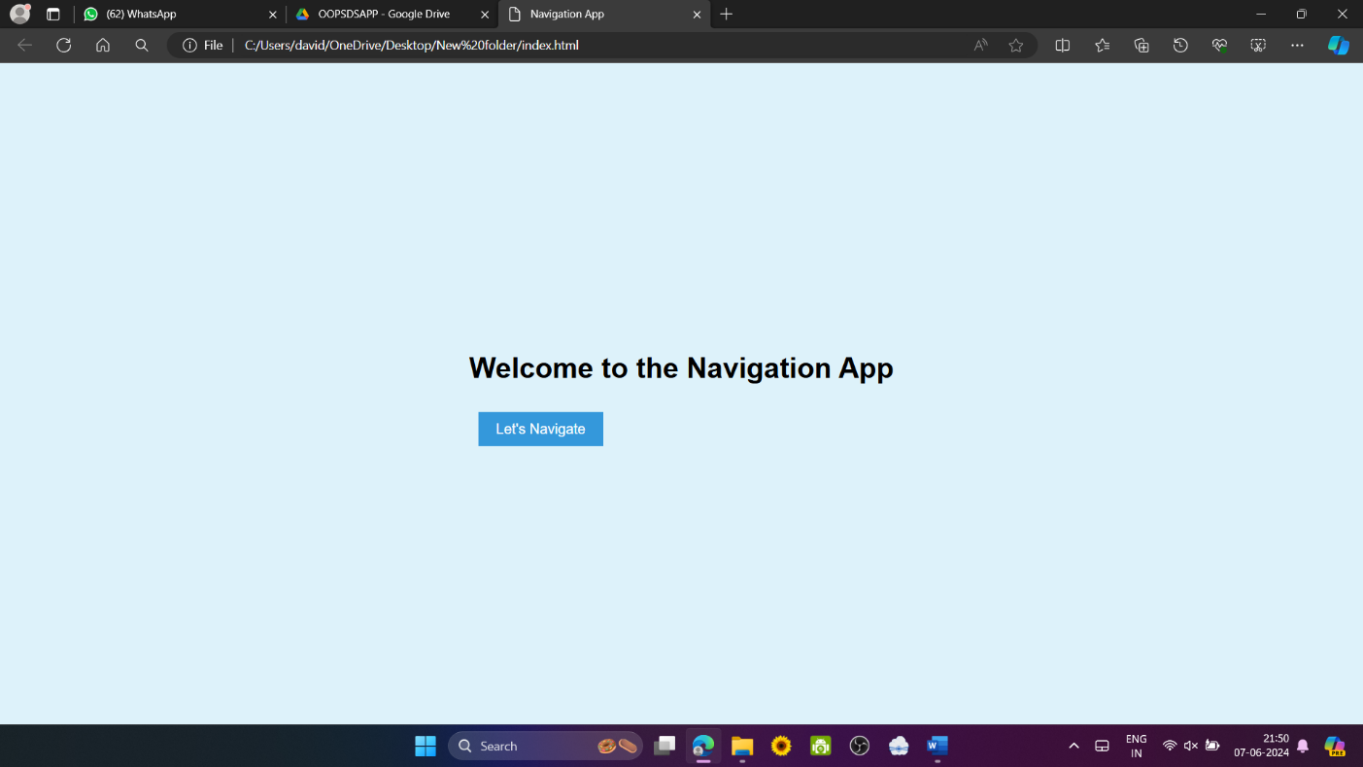

Fig 5.1 Welcome Page
User enters into Gping Welcome page

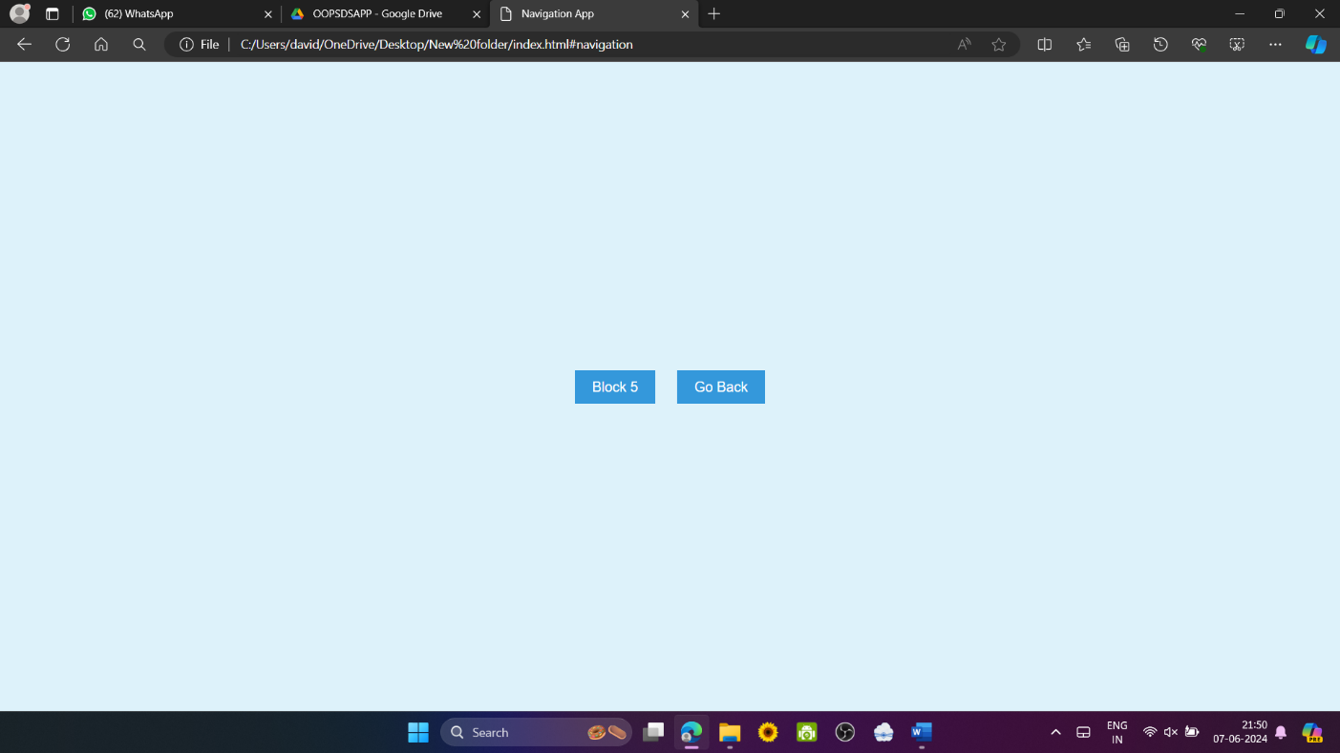

Fig 5.2 Block page
Click on the required block button to show the available Floors in the block

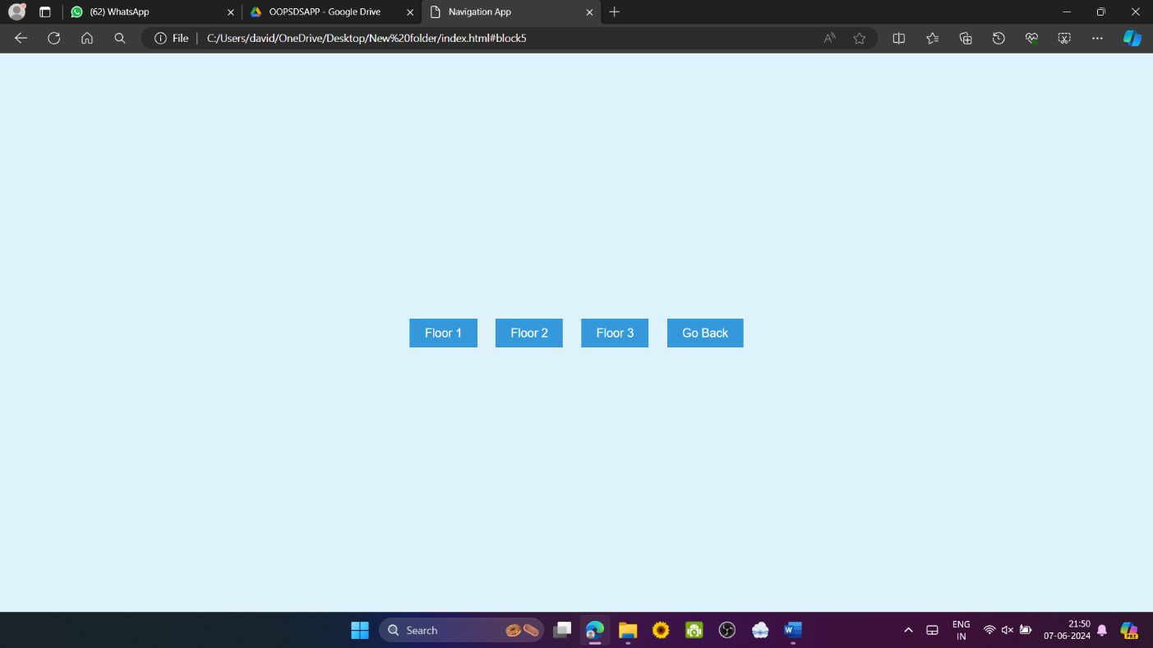

Fig 5.3 Floor Page
User can Choose the floor to continue or go back to the previous page

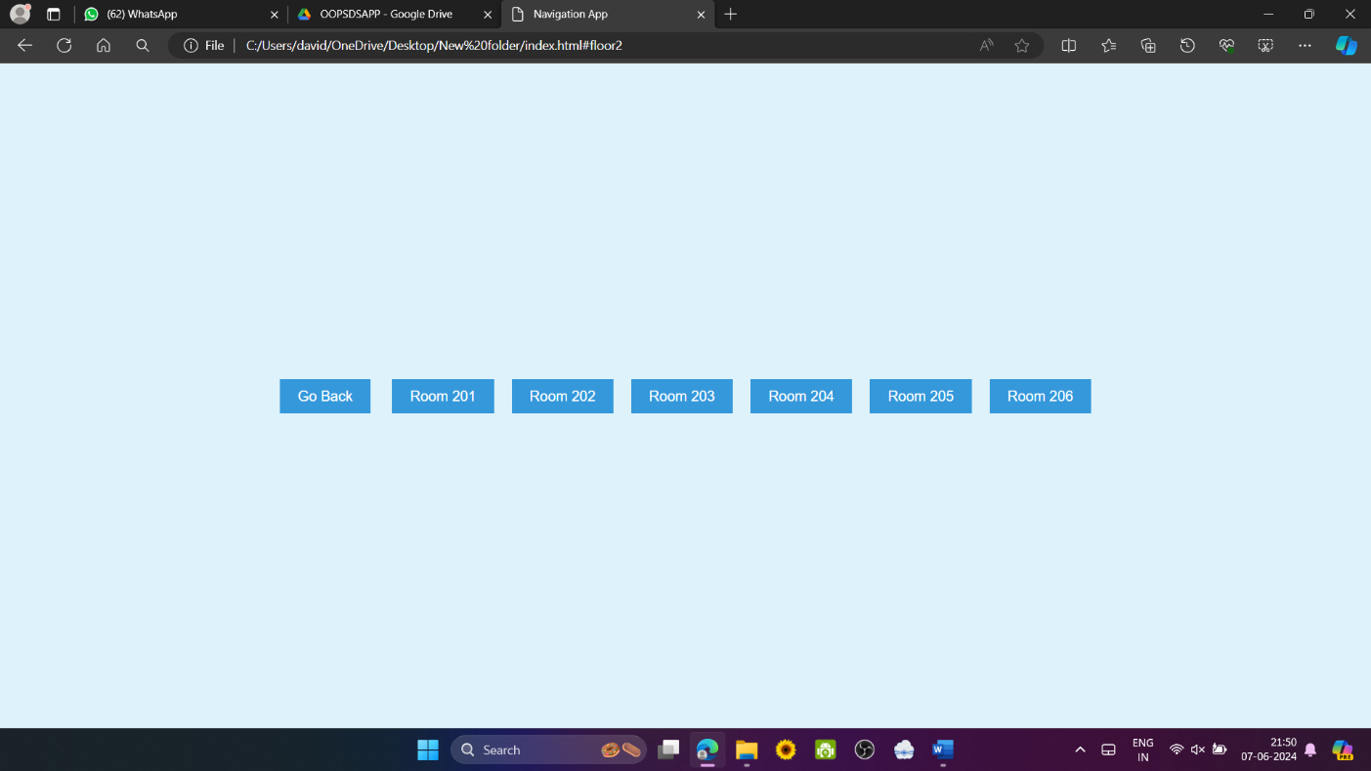

Fig 5.4 Room Page
As the floor is chosen, now the user has to select the room number to connect

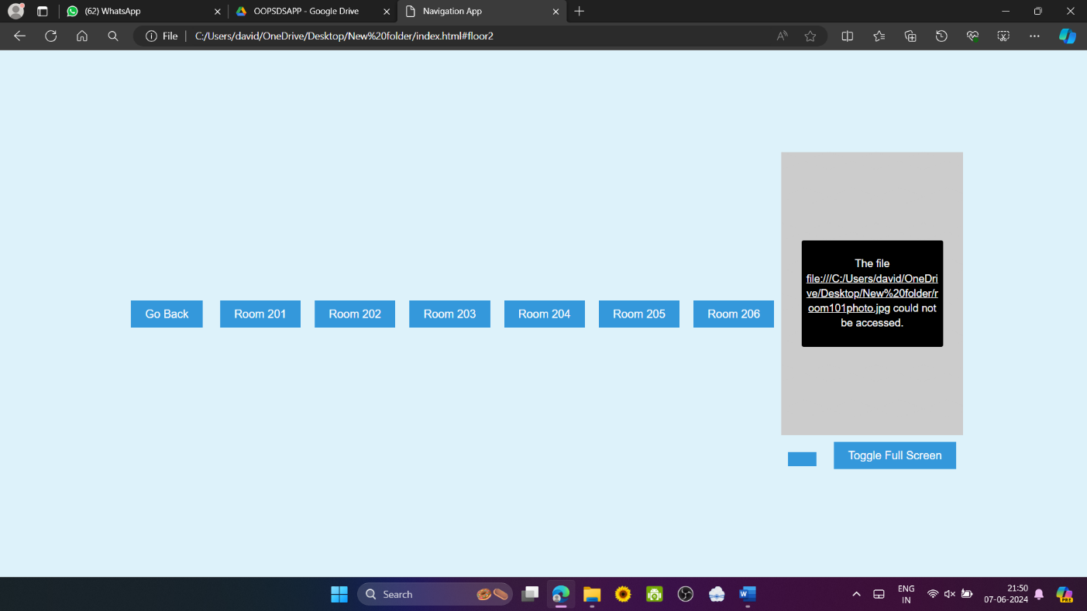

Fig 5.5 Route map
Users view the root to required location

6. CONCLUSION

The GPING Navigation Application represents a significant advancement in the way college campuses are navigated. By leveraging the principles of design thinking, GPING addresses the diverse needs of students, faculty, and visitors, providing a user-centric and efficient solution for campus navigation. The application’s key features, including an interactive map interface, searchable room database, customizable routes, real-time location tracking, and offline functionality, collectively enhance the user experience by making navigation intuitive, reliable, and adaptable. Integration with college databases ensures that users have access to the latest information on courses, events, and facilities, while robust privacy and security measures protect user data. The continuous iteration and responsiveness to user feedback underscore GPING's commitment to evolving in line with user needs. Overall, GPING sets a new standard for navigation tools in educational environments, simplifying the complexities of campus navigation and improving the overall user experience.

7. FUTURE SCOPE

The future scope of the GPING project is vast, with numerous opportunities for enhancement and expansion. One promising area is the integration of advanced Augmented Reality (AR) features, which can provide an immersive navigation experience by overlaying directional arrows and contextual information in real-time as users navigate the campus. Additionally, there is significant potential in enhancing accessibility features to support users with disabilities, including voice-guided navigation, tactile feedback for visually impaired users, and optimized routes for wheelchair accessibility. Leveraging machine learning algorithms to offer personalized recommendations based on user preferences and behavior can further tailor the user experience, suggesting optimal study spots, eateries, or routes. Social integration features, enabling users to connect with peers, share locations, and collaboratively plan routes or events, can foster a stronger sense of community. Furthermore, expanding GPING's capabilities to integrate with wearable devices and IoT (Internet of Things) technology can provide seamless and real-time updates, enhancing the overall efficiency and user experience of campus navigation..
8. REFERENCES

https://chatgpt.com/
https://navigine.com/industries/universities/
https://www.mappedin.com/resources/blog/implementing-a-successful-campus-navigation-app/

